

HATE SPEECH

RECOGNITION MODEL FOR

SOCIAL MEDIA PLATFORMS



**INTRODUCTION**

Hate speech is abusive or discriminatory

language targeting specific groups based on

traits like race or gender. It fosters social

division, harms mental health, and can incite

violence. As hate speech grows on social media,

automated detection models are crucial for

scalable, real-time moderation.



**OBJECTIVES**

The primary goal is to create a reliable and

scalable hate speech detection model.

Secondary objectives include reducing

false positives and negatives, adapting to

evolving language and context, and

ensuring fairness across platforms.

4

o



1:

Data Collection

Source datasets from social

media platforms.Include multilingual and context-

specific data.

2:

Data PreprocessingText cleaning: Remove

noise, stop words, and special characters.

Tokenization and stemming/lemmatization.

Labeling data for hate speech and non-hate

speech.

3:

Model SelectionTraditional models: Logistic

Regression, SVM.Advanced models: LSTM, BERT,

Transformer-based architectures.

***Methodology***

***Overview***

4:

Training & Evaluation

Train using labeled

datasets.Evaluate performance with metrics

like accuracy, F1-score, precision, and recall.

5:

Deployment Integrate into a social media

moderation tool.



**DATA COLLECTION DETAILS**

Data is sourced from platforms like Twitter,

Reddit, Facebook, and publicly available

datasets on Kaggle to ensure diverse and

representative content for training the

model.

Multilingual Data: Covers multiple

languages for broader applicability.

Contextual Conversations: Includes sarcasm

and indirect hate speech.

Balanced Data: Ensures equal

representation of hate and non-hate

content.

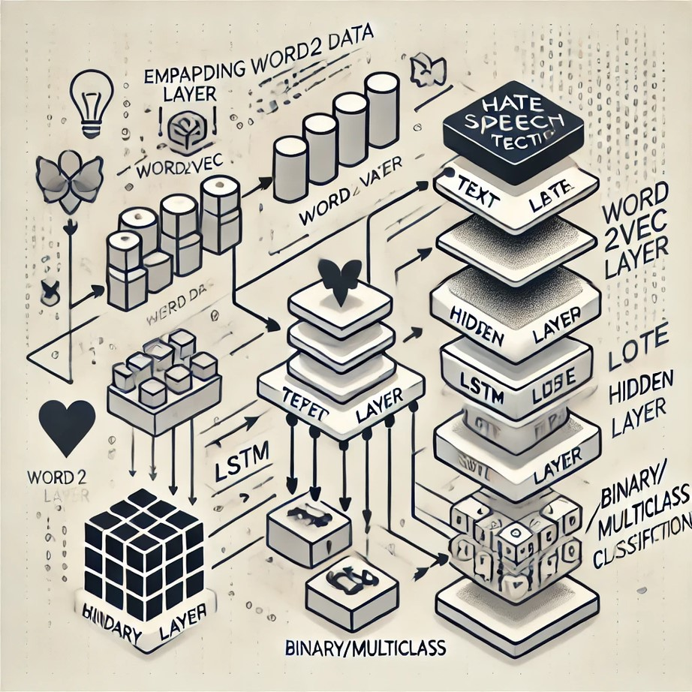

**MODEL ARCHITECTURE**

1

.Input Layer: Processes text data.

2.

Embedding Layer: Converts text

inumerical vectors using techniques like

Word2Vec or zGloVe.

3.

Hidden Layers: Utilizes LSTM or

Transformer layers for context understanding.

4.

Output Layer: Classifies text into

binary(hate/non-hate) or multiclass categories.



Evaluation Metrics:

1

.Accuracy

2

.Precision

3

.Recall

4

.F1-Score

5

.Confusion Matrix

**RESULTS AND**

**PERFORMANCE**

Key Insights:

1

.Model performance across languages.

2

.Success in detecting subtle hate speech.



**CHALLENGES AND**

**LIMITATIONS**

1

.Data Challenges

:

Imbalanced datasets.

Ambiguous or

sarcastic hate speech.

2.

Model Challenges:

Bias in training data.

Difficulty in detecting

contextual hate.

3.

Ethical Concerns:

Misclassification and

freedom of speech.



Contextual and Multimedia Analysis:

Extend detection to images, videos, and

audio content on social media platforms.

Multilingual Support: Enhance the model

to identify hate speech in more languages

and dialects across social media.

These improvements will make the model

more effective and comprehensive in detecting

harmful content.

**FUTURE SCOPE**

Applications:

Real-time Moderation: Enable instant hate

speech detection on social media

platforms for better content management.

Government and NGO Integration:

Support monitoring tools for governments

and NGOs to track and address hate

speech at a larger scale.

4

o mini

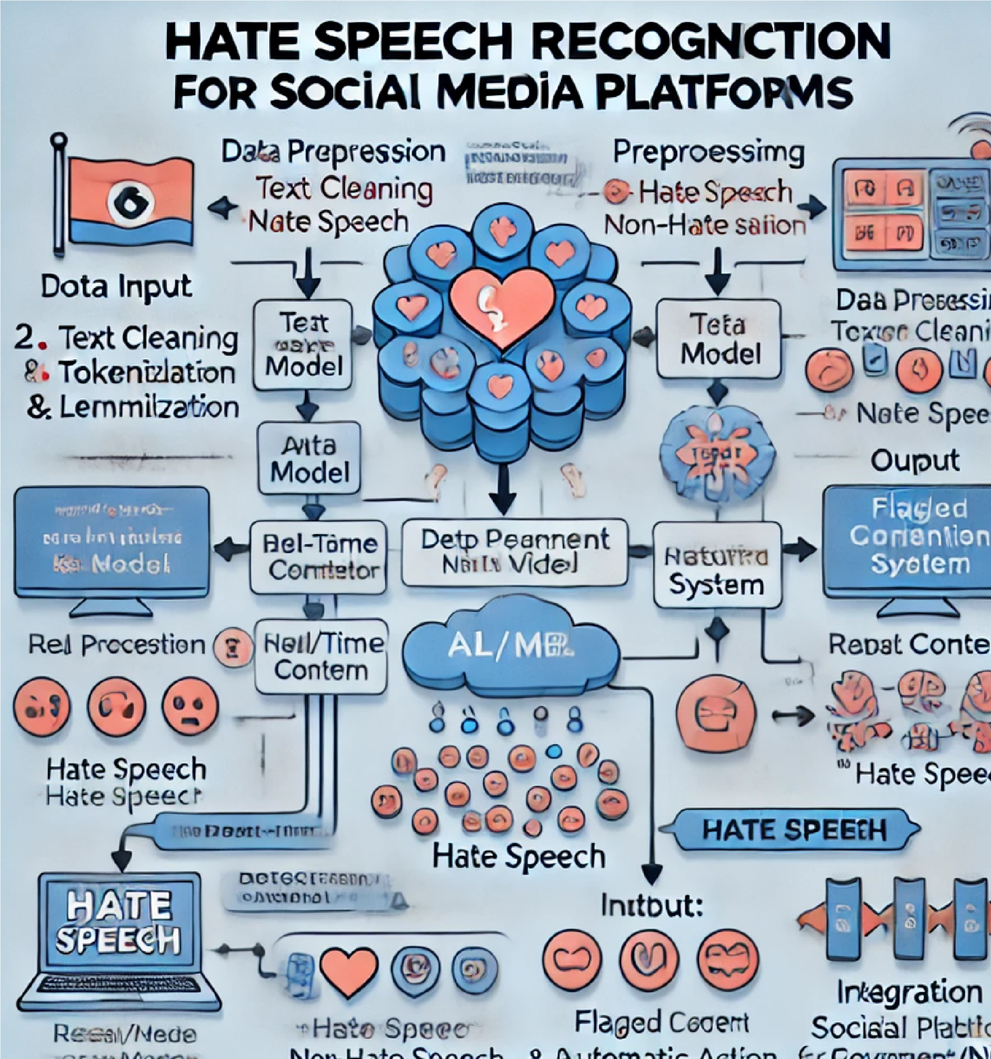

**CONCLUSION I**

Hate Speech Detection: Crucial for

protecting users and promoting respectful

online environments.

Role of AI: AI helps in real-time

identification of harmful content, ensuring

safer social media spaces.

Collaboration: Ongoing teamwork between

developers, platforms, and regulators is

essential to address challenges and uphold

ethical standards.

4

i

i



FOR YOUR ATTENTION

*By :-*

*Rohit Raghav -E23CSEU2461*

**THANK YOU!**